Javascript
Questionnaires

Questions / Topics
Eloquent JavaScript Chapter 6
- OOP
- Class
- Constructor
- Differentiate between constructor function and class
- Encapsulation
- Prototype
- Method that returns a value’s proto
- Who has proto?
- Result from Object.create(null)
- Maps
- Class “Map”, methods
- Use of {}.hasOwnProperty(“name”)
- Symbols
- Didn’t understand Iterator Interface
- Polymorphism
- Inheritance
- Instanceof

Chapter 6 Eloquent JS Answers
- Object oriented programming is a loosely defined paradigm of work not all coders agree with. It suggests that all pieces of functional code should be self contained, easy to update and independent from the whole, with the purpose of easing maintenance and updates while promoting re-usability and clarity. No pieces of a program must be aware of the functionality embed within another to work together.
There are several types of OOP.
- They are a recent syntax that intends to replace constructor functions as the new to-go method for creating objects, specially if many are to be created and have to be edited frequently. Classes create a new prototype with custom methods and properties to be used as a template that updates all items that is based on upon modification and that can be extended with additional functionality or even inherit its attributes to a new class if desired.
- CF simply create a new object based on object.prototype, also known as an empty object {} and give that particular value new methods and properties to hold the desired information. They use the new operator to make new objects.
- Syntax wise, people are agree on writing constructor functions (CF) with the first letter uppercased while classes do not do this. CF create an empty object, fill it with the parameters given and return it. Classes make a new prototype on the fly from where a new object will be built with the necessary methods already existing and only needing for values to be added. It might seem very similar… and it is, with some critics calling classes “syntactic sugar” but for the sake of readability and uniformity, it is advised to transition into classes or directly go on to use them instead of CF.
- Functionality should be stored within a scope and be completely separated from any other piece of code, only being able to communicate with the exterior by getting input arguments passed to it and outputting other values with the return keyword bound to methods inside it. Some OOPs suggest to even keep as many variable declarations, values and executable pieces out of the global scope, instead relegating such “pollution” to be stored within large objects that contain massive functionality, referred as modules.
- A default slate for each value type in the language that already has a large number of properties and methods bound to it. All new instances of such value will be based upon the originals and inherit all of them.
Methods such as map, filter, toString or round belong to each of their respective value prototypes (Array, String, Math) and while they can be overwritten it’s NOT recommended because it can compromise the entire script sheet.
- Object.getPrototypeOf(varName)
- Objects, functions, strings, numbers, arrays …
- An object with no inherited methods or properties, only the ones given after creation. They were often used before Maps were added.
- Maps are an object that do not inherit most properties from other objects and thus are safe to make clean objects that only contain the properties one desires.
- Maps contain get, set and static methods as default. They return/modify information or change things within the original constructor.
- It returns true or false if the string passed is one of the properties or methods it contains. Useful for finding information.
- They are a type of value that is completely unique after creation. They can only be made with special syntax and a string (or number that will be turned into a string). Regardless of what this string contains it is impossible to match it with anything but itself, even if the string content is the same word for word. Symbols are a useful way of creating safe names for methods without the problem it will conflict with other methods in other objects named in the same way, creating inconsistent results.
- F
- The idea that objects built on prototypes previously known can have their own copies of some methods changed to be more useful for the purpose of the object. In the example, toString was changed on the custom prototype so it returned something better.
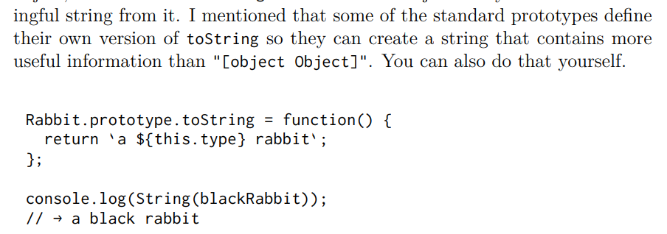
- F
- To know if something is derived from a prototype compared against this operator returns true or false. It also reviews all prototypes the comparisons are based from, so those different might report true if they are extended from the same prototypes. It evaluates object against constructor.

Fundamentals
- Methods to iterate through an object? Give a brief explanation of each.

Answers for Fundamentals
- For … in loop, iterates through each of the properties of an object, can be problematic because it will read through an entire prototype if not told to avoid it. Object.keys returns an array with the names of each of the properties in the object. Object.values returns an array with each of the values of each property in the objct. Object.entries returns an array full of arrays, each filled with two elements, the first being the name of the key and the second the value.

